INFORMATION FORM
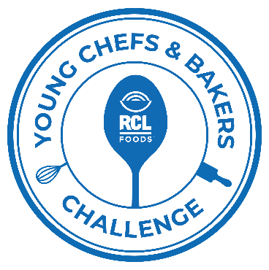
To enter the RCL Young Chefs & Bakers Challenge:
- Fill in the details below.
- Email the information form together with the 2 recipe templates and images to competitions@sachefs.co.za by no later than 31 July 2023

 | Chef A | Chef B
First Name(s):

Surname:

Date of Birth YYYY/MM/DD:
Age @
12th Oct 2023
ID Number:

Mobile Number

Email Address

Province

Culinary School

